Godaddy, Contact Form 7, Gmail (company), Postman SMTP

1.- Able to setup Postman SMTP as suggested by:

case CPanel on Linux, smpt: localhost, port 25, authentications void.

2. On Postman used domain mails.

3. Contact Form 7 didn't work.

Found that it didn't work when sending mail to domain.

It did work sending mail to other domains, even setting Reply-To: customer-email

4.- Need to sort out what to do to send mail to same domain.

TRY 1: didn't work

On contact form 7

a) change To:

was : ajoposor@gmail.com

try: info@kapitalvalue.com

change from:

was: [customer-name] <info@kapitalvalue.com>

try: : [customer-name] <ajoposor@gmail.com>

Try 2: WORKS

TO: ajoposor@gmail.com

FROM: [customer-name] <ajoposor@gmail.com> (message then displays From: info@kapitalvalue.com On Behalf Of: Antonio Osorio, es decir, no tomó en cuenta el ajoposor@gmail.com en from)

Try 3: DIDN'T WORK

to: info@kapitalvalue.com

from [customer-name] <info@kapitalvalue.com>

5. find out if gmail api credentials work.

Last working settings:

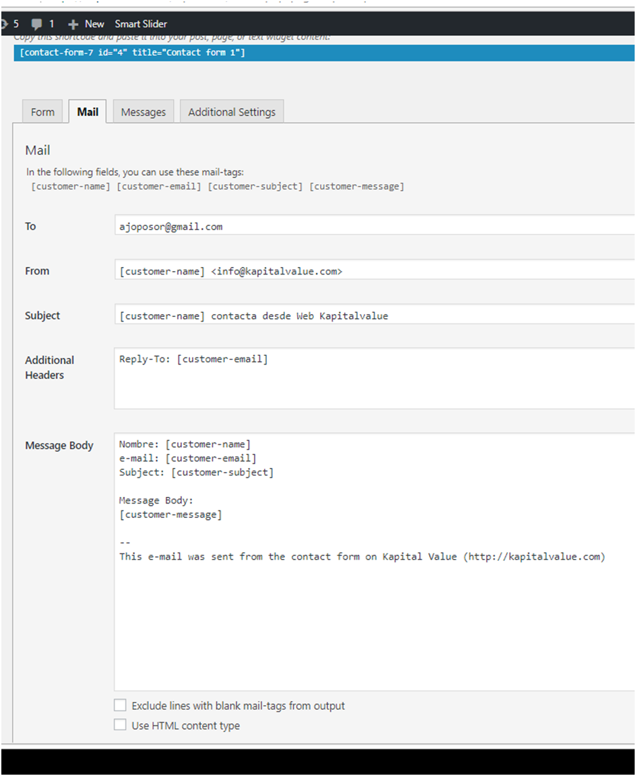

option 1: Postman working settings using dodaddy mail server localhost on port 25 no username or password

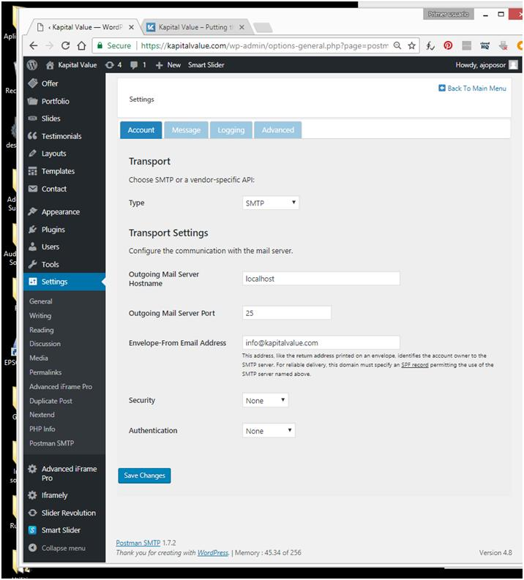

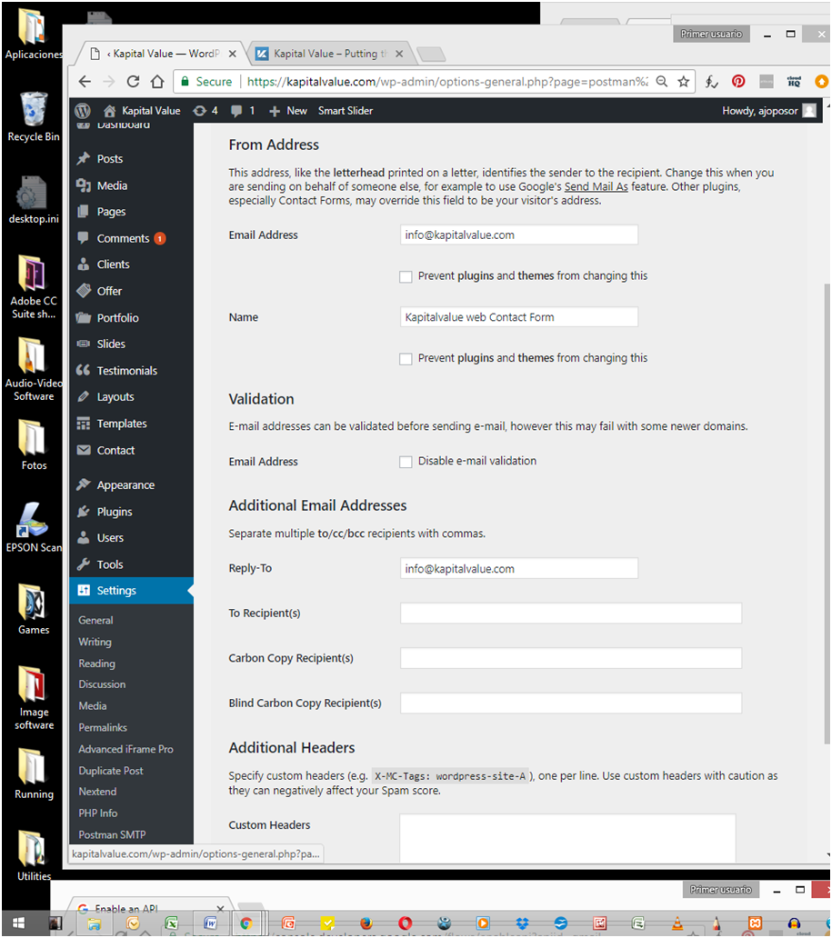

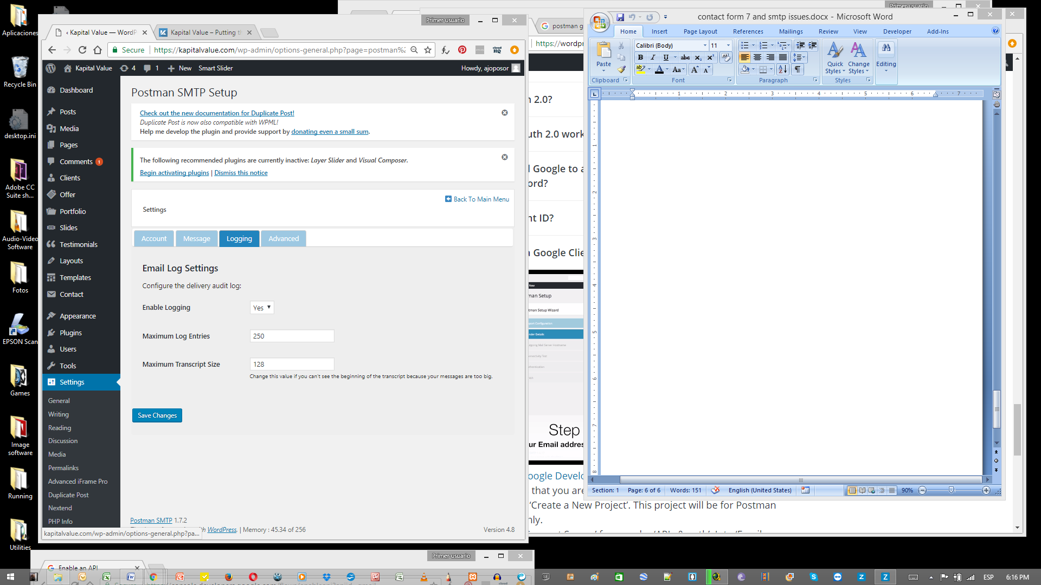

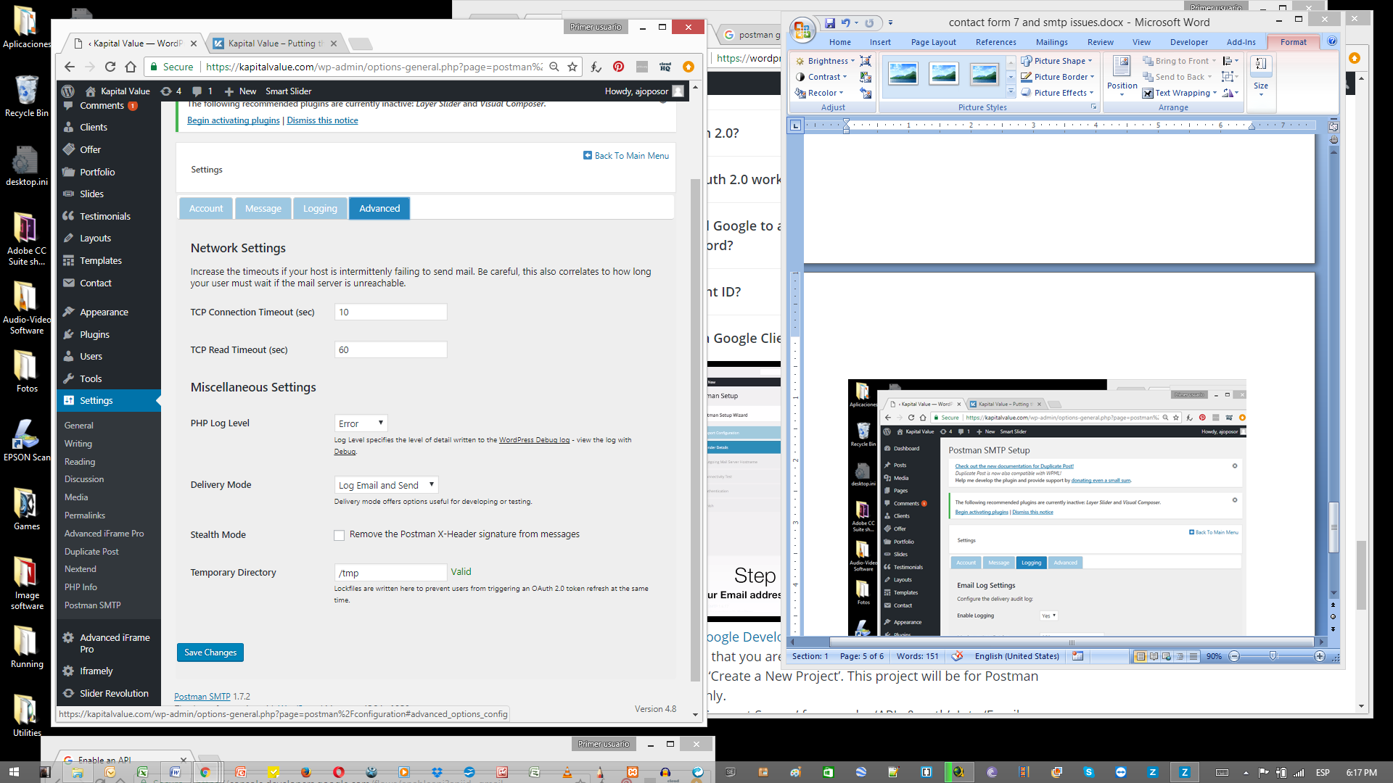

option 2 in postman, using gmail api,

Account / transport / type Gmail API

Authentication, get client ID and Client secret from google api de kapital value

Message, email addres, info@kapitalvalue.com, name kapitalvalue Contact Form, Reply-To info@kapitalvalue.com